**RESEARCH PROJECT QUESTIONS**

**Title of Project:** **Developing a user-friendly and accessible terrain generation and editing tool**

**Question: What is your Occupation**

**Question: What is your Age**

**Question : What is your Gender**

**Question: What would you describe the power of your computer to be from very weak to very strong**

**Question: how would you rate your ability on a computer from very low(never used a computer) to very high(can do everything with ease on a computer)**

**Question: Have you used the tool**

**Yes/No**

**Question: Have you used a similar tool before**

**Question: How easy did you find the tool to use**

**Question: How easy was it to find features within the tool**

**Question: was the layout intuitive**

**Question how would you change the layout to better fit you**

**Question: When using the tool what was your performance like from Very low(Consistently low frame rate, frame drops, stutters and freezes) to Very high(No Freezes or stutters, consistently high frame rate, no performance drops)**

**Question. Did you achieve what you wanted in the tool**

**Question. Effort : How much time did it take you to use the tool and achieve**

**Question: How long did it take for you to feel like you understood all the functions of the tool.**

**Question. How mentally demanding was using the tool**

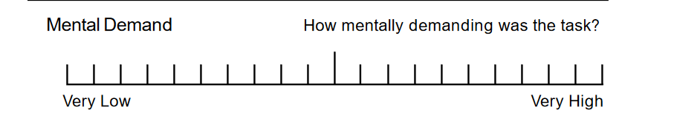

**Question. When using the tool were there particular features that frustrated you or didn’t work as you expected and how would you want them to be improved**

**Question. Do you have any ideas of what can be improved**

**Question. What is the one thing you wish the tool could do that it cant do already**

**Question. what would you use this tool for**

**Question: rate both tools out of 10**

**What are things you noticed that were good and bad about both tools**

**Question. Comparing the two tools if you were going to use one to create a terrain what would you choose**

**Question. What about that tool makes it preferred to the other.**

**Question: When considering someone with no knowledge of either tools who wants to quickly develop a terrain for their game what tool would you recommend**